ASSIGNMENT SUBMISSION COVER SHEET

cse25-255
Student Id:

Shepherd Tathego
Student names:
cse25-255@thuto.bac.ac.bw
Student email:

Cohort: 2026

SCIS WMD_2026 A01
Assignment title:

Date of submission:
Computer Systems Engineering
Programme of Study:

YEAR 1
Year of Study:

Intellectual property statement
By checking the box below, I certify that this assignment is my own work and is free from plagiarism. I understand that the assignment may be checked for plagiarism by electronic or other means and may be transferred and stored in a database for the purposes of data-matching to help detect plagiarism. The assignment has not previously been submitted for assessment in any other unit or to any other institution. I
have read and understood the Botswana Accountancy College plagiarism guidelines policy.
☐ Agree Signature…………………………………….
Date………………………………………….

WEBSITE SPECIFICATION DOCUMENT

OBJECTIVES & GOALS
The main objective of the PharmaLink website is to provide a user-friendly online platform where individuals can conveniently access a wide range of pharmacy services and products from the comfort of their homes. The website aims to bridge the gap between patients and the pharmacy by offering easy access to healthcare products, professional guidance, and reliable medical information. One of its key goals is to enable users to browse through various categories of medicines and healthcare products, compare options, and make informed purchasing decisions without the need to physically visit a pharmacy. The platform is designed to simplify the purchasing process by allowing secure online transactions and where possible, delivery services. PharmaLink also seeks to enhance communication by providing multiple contact options, such as online consultations, inquiries, and support services, ensuring that users can easily reach qualified pharmacy personnel when needed. The website also strives to save time for users, especially those with busy schedules or limited mobility, while also promoting better health awareness by offering detailed, accurate, and up-to-date information about medicines, their uses, dosages, and potential side effects. PharmaLink aims to improve accessibility, convenience, and overall customer satisfaction in the delivery of pharmacy services.
TARGET AUDIENCE
The site targets users:
- Aged 18-60 years
- All genders
- Located in Gaborone and surrounding areas
Includes patients, caregivers and working adults
Technical Aptitude
- Basic internet skills
- Able to use smart phones and simple websites
- Have access to the internet

TYPE OF WEBSITE
The PharmaLink website falls under the category of a healthcare and e-commerce website. It is specifically designed to combine the provision of healthcare information with online purchasing functionality. The platform allows users to easily access medicine listings, , access online consultations, view detailed health-related information and find important contact and location details for the pharmacy. It also supports online transactions, enabling users to conveniently pay for bookings, and purchase medicines and healthcare products. This integration of healthcare services and e-commerce functionality ensures that users can meet their medical needs efficiently in one centralized digital platform.

INFORMATION DESIGN AND TAXONOMY
Information Architecture
The PharmaLink website is structured in a clear and logical manner to ensure that users can easily find the information they need and navigate smoothly between different pages. The design focuses on simplicity and usability, allowing both first-time and returning users to interact with the website without confusion. Content is carefully organized into main sections based on common user needs, such as browsing medicines, purchasing products, accessing healthcare services, and obtaining support or additional information.
The website follows a hierarchical layout in which information is arranged from general to more specific levels. The structure begins with the Home Page, which serves as the main entry point and provides an overview of the website, including highlights of products, services, and important announcements. From the Home Page, users can easily navigate to other key sections of the website through a consistent navigation menu.
The main sections of the website include:
- Home - Provides an overview of the website, featured products, and quick links to important areas.
- About Us - Contains information about the pharmacy, its mission, vision, and background.
- Products - Displays available medicines and healthcare products, organized into categories for easy browsing.
- Product Review-
- Services - Outlines the services offered, such as consultation bookings, prescription assistance, skin care routine services and health advice.
- Cart - Allows users to view selected items, manage quantities, and proceed to check out for purchase.
- Check out -This is where users enter their details and confirm payment after selecting items from the cart. It makes the purchasing process clear and organized.
- Contact Us - Provides contact details, location information, and a form for user inquiries or support.
- FAQs - Offers answers to commonly asked questions to help users quickly resolve common issues.
This structured approach ensures that users can move efficiently through the website, improving usability, accessibility, and overall user experience.

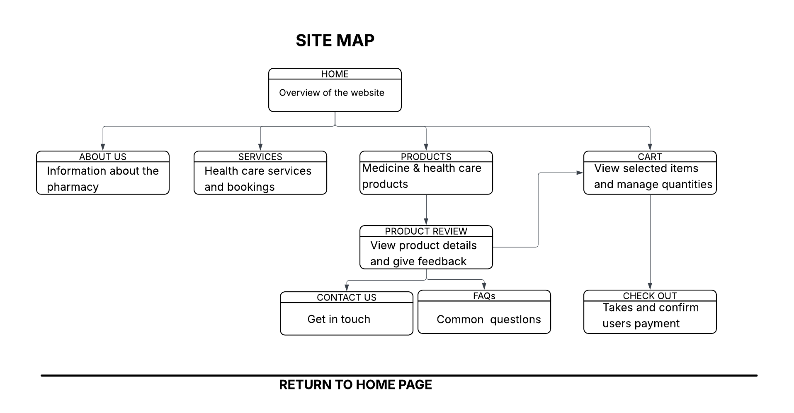

TECHNICAL BRIEF
Technologies Used:
- HTML – for structuring web pages
- CSS – for styling and layout
- Bootstrap – for responsive design and layout
- JavaScript – for adding interactivity and making the website more alive
Development Tools:
- Visual Studio Code – for writing and editing code
- GitHub – for version control and hosting the website
Design & Planning Tools:
- Lucid chart – for site maps and navigation flowchart
- Microsoft Word – for documentation
Graphics & Resources:
- Free online images (medicine and healthcare products)
- Basic graphic tools (for simple design elements)

These tools are suitable for a basic healthcare e-commerce website since they support responsive design, easy development, and simple deployment. They also match the required level of complexity for the project.

PAGE TEMPLATE DESIGN

